GNU Octave, version 3.8.2
Copyright (C) 2014 John W. Eaton and others.
This is free software; see the source code for copying conditions.
There is ABSOLUTELY NO WARRANTY; not even for MERCHANTABILITY or
FITNESS FOR A PARTICULAR PURPOSE. For details, type 'warranty'.

Octave was configured for "i586-pc-linux-gnu".

Additional information about Octave is available at http://www.octave.org.

Please contribute if you find this software useful.
For more information, visit http://www.octave.org/get-involved.html

Read http://www.octave.org/bugs.html to learn how to submit bug reports.
For information about changes from previous versions, type 'news'.

a = 1.000000
l = 1.000000
T = 0.050000

ε =
1.0000e-12

Параметры сетки:
n = 16
k = 8

hx = 0.062500
ht = 0.006250

Начальное возмущение =
@(x) 0.2 * sin (2 * pi * x)

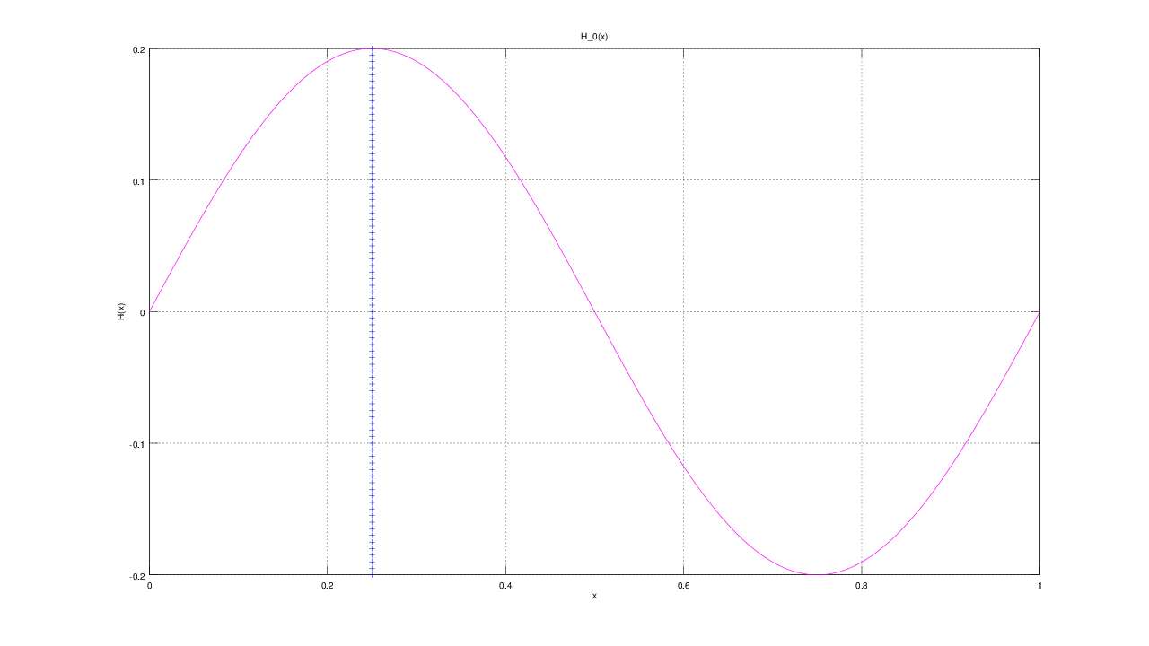

Всего демпферов: 1

Демпфер # 1

x_1 = 0.250000

Верхнее предельное значение w_1(t) =
NaN

Нижнее предельное значение w_1(t) =
NaN

Управляющая функция w_1(t):
-5.6869e+03
4.0961e+03
-3.1850e+03
1.2350e+03
1.9902e+03
-4.1672e+03
8.2369e+03
-1.2230e+04
1.5602e+04

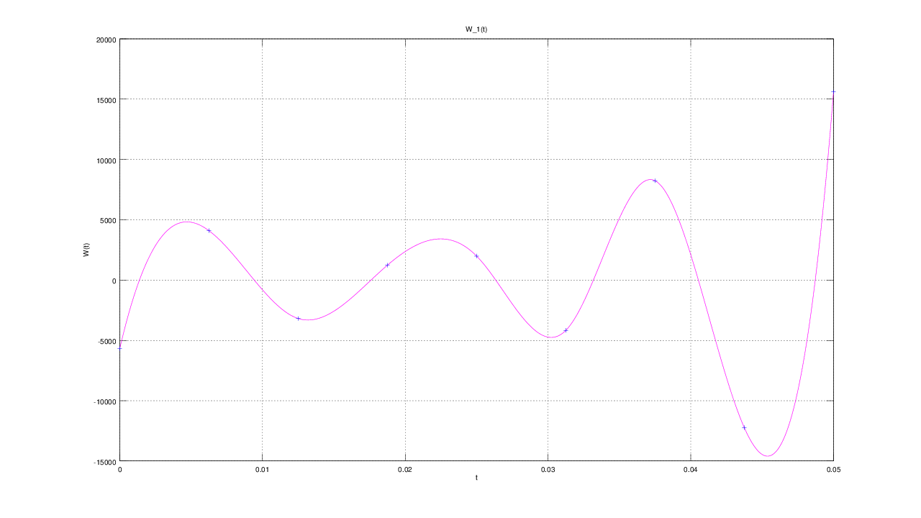

E(T) =
1.9245

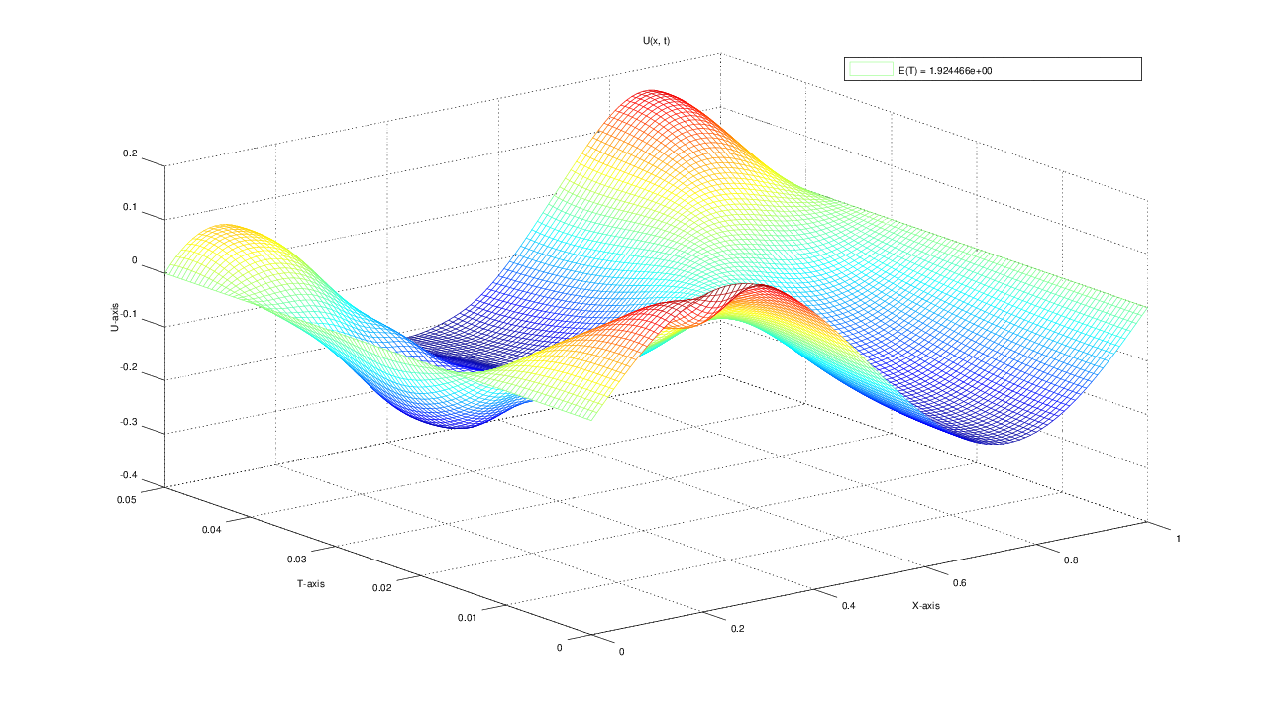
u(x, t)
T = 0.000000: 0.000000 0.076537 0.141421 0.184776 0.200000 0.184776 0.141421 0.076537 0.000000 -0.076537 -0.141421 -0.184776 -0.200000 -0.184776 -0.141421 -0.076537 -0.000000
T = 0.006250: 0.000000 0.072450 0.119460 0.120202 0.084886 0.120336 0.120229 0.074644 0.003497 -0.072112 -0.136550 -0.179319 -0.194259 -0.179453 -0.137319 -0.074307 0.000000
T = 0.012500: 0.000000 0.031165 0.030489 0.013256 0.034095 0.016332 0.038506 0.043885 0.007368 -0.055184 -0.117566 -0.161058 -0.177041 -0.164134 -0.125583 -0.067904 0.000000
T = 0.018750: 0.000000 -0.058090 -0.088482 -0.087383 -0.113858 -0.070830 -0.060322 -0.036540 -0.020058 -0.036956 -0.079637 -0.122422 -0.144700 -0.138976 -0.107797 -0.058507 0.000000
T = 0.025000: 0.000000 -0.111228 -0.169347 -0.176990 -0.109970 -0.142313 -0.130979 -0.117795 -0.087495 -0.053467 -0.044281 -0.062904 -0.088048 -0.097581 -0.082649 -0.046900 0.000000
T = 0.031250: 0.000000 -0.094910 -0.167791 -0.169746 -0.171449 -0.154616 -0.177948 -0.170704 -0.146969 -0.102308 -0.048040 -0.014254 -0.013367 -0.029384 -0.037882 -0.026514 0.000000
T = 0.037500: 0.000000 -0.044158 -0.067030 -0.099122 -0.113629 -0.162481 -0.185020 -0.201544 -0.182129 -0.139722 -0.078573 -0.008846 0.041527 0.054513 0.039417 0.017663 0.000000
T = 0.043750: 0.000000 0.033819 0.029415 -0.017254 -0.098538 -0.155847 -0.193315 -0.205258 -0.199698 -0.159820 -0.097934 -0.022803 0.057208 0.115791 0.124796 0.079256 0.000000
T = 0.050000: 0.000000 0.061978 0.063616 0.005845 -0.093840 -0.149265 -0.196798 -0.211395 -0.198349 -0.165971 -0.102573 -0.019445 0.066095 0.135666 0.157840 0.107403 0.000000

